Personal Information
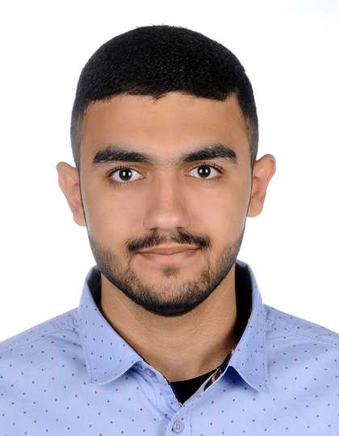
Name: Jaffar Mohammed Ahmed.
Address: H: 1900, R: 2730, SAR527 - Bahrain.
Email: jaffermohdaj98@gmail.com
Date of Birth: 20/10/1998
Mobile No: 39994814
CPR No: 981006531
Social Situation: Single.
Nationality: Bahraini.

Education Qualification:
2013–2016 Graduated from Jidhafs secondary Technical boys school.
2009-2015 Certification from British Language Centre.
*English courses.
2015-2015 Certification from Tamkeen.
*Training program to prepare a project "A9eel".

Capabilities and Skills:
- Driving License.
- Flexible and creative.
- Excellent time management.
- Excellent communication skills
- Deals effectively with problems.

Work Experience:

2015 Training in Al-saffer Electricity company.
*Extension of Electric wires.
Language:
- Arabic: Mother language
- English: Good in speaking, reading and writing.

Interest and Hobbies:
- Basketball and football
- Reading and writing.

References:
Mahammed Ahmed Jassim
Mobile No: 33156651

